OTIENO TRAZZY AMOLO

INTE/MG/2679/09/22

NUMERICAL ANALYSIS AND PROGRAMMING

CAT II

a)f(x1)=-2

f(x2)=4

f(x1) . f(x2)<0

f(-2) . f(4)<0

xm=x1-f(x1) . (x2-x1)/f(x2)-f(x1)

xm=1+2* (3-1)/4+2

xm=1.6667

Iteration 2:

f(xm)*f(x1)

f(1.6667)*f(1)=1.7778

x1=xm=1.6667

f(1.6667)=-0.8889

f(3)=4

xm=1.6667+0.8889*(3-1.6667)/4+0.8889

xm1=1.9091

Iteration 3:

f(xm1)*f(x1)

f(1.9091)*f(1.6667)=0.2345

f(x1)=f(1.9091)= -0.2635

f(x2)=f(3)=4

xm2=1.9091+0.2635*(3-1.9091)/4+0.2635

xm2=1.9091+0.2635*0.2559

xm2=1.9765

b)

i)Differentiation

import numpy as npy

def f(x):

return x**3 + 2*x**2 + x + 1

x = np.linspace(0, 10, 100)

y = f(x)

dy_dx = np.gradient(y, x)

print(f"The numerical derivative is: {dy_dx}")

ii)Numerical Integration

import numpy as np

def f(x):

return x**3 + 2*x**2 + x + 1

x = np.linspace(0, 1, 1000)

y = f(x)

integral = np.trapz(y, x)

print(f"The result of the numerical integration is: {integral}")

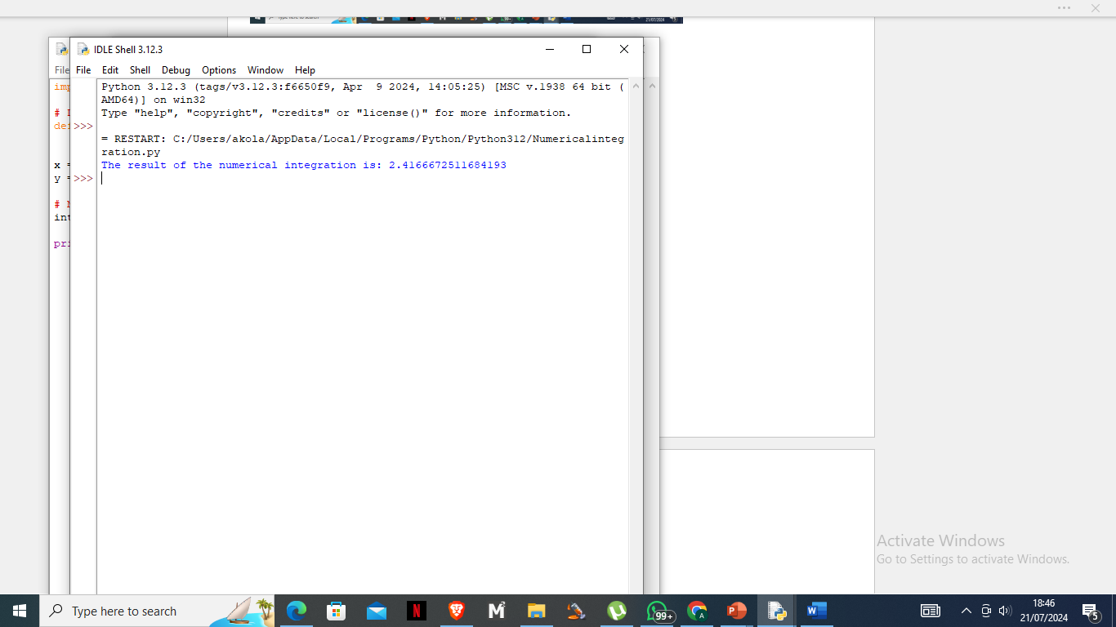

iii)Curve Fitting

import numpy as np

import matplotlib.pyplot as plt

# Define the function to fit

def func(x, a, b, c):

return a * np.exp(b * x) + c

# Generate some data

xdata = np.linspace(0, 4, 50)

ydata = func(xdata, 2.5, 1.3, 0.5) + 0.2 * np.random.normal(size=len(xdata))

# Define the cost function for curve fitting

def cost(params, x, y):

a, b, c = params

return np.sum((y - func(x, a, b, c))**2)

# Initial guess for the parameters

initial_guess = [1, 1, 1]

# Perform the curve fitting using gradient descent

from scipy.optimize import minimize

result = minimize(cost, initial_guess, args=(xdata, ydata))

popt = result.x

print(f"Fitted parameters: {popt}")

# Plot the data and the fit

plt.scatter(xdata, ydata, label='Data')

plt.plot(xdata, func(xdata, *popt), label='Fit', color='red')

plt.legend()

plt.show()

iv)Linear Regression

import numpy as np

import matplotlib.pyplot as plt

x = np.linspace(0, 10, 100)

y = 3 * x + 7 + np.random.normal(size=x.size)

A = np.vstack([x, np.ones_like(x)]).T

slope, intercept = np.linalg.lstsq(A, y, rcond=None)[0]

print(f"Slope: {slope}, Intercept: {intercept}")

plt.scatter(x, y, label='Data')

plt.plot(x, slope * x + intercept, color='red', label='Fit')

plt.legend()

plt.show()

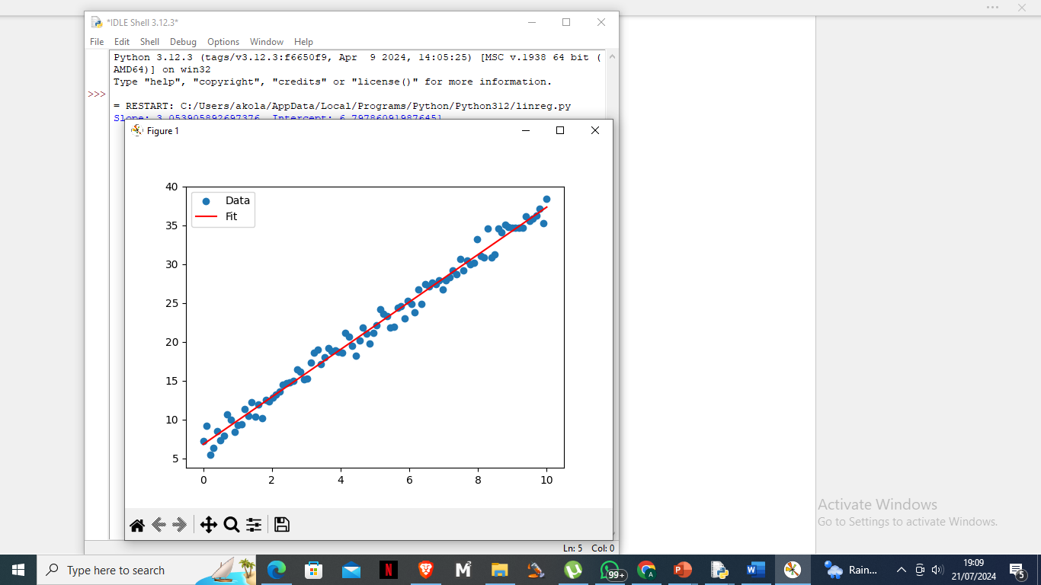

v)Spline Interpolation

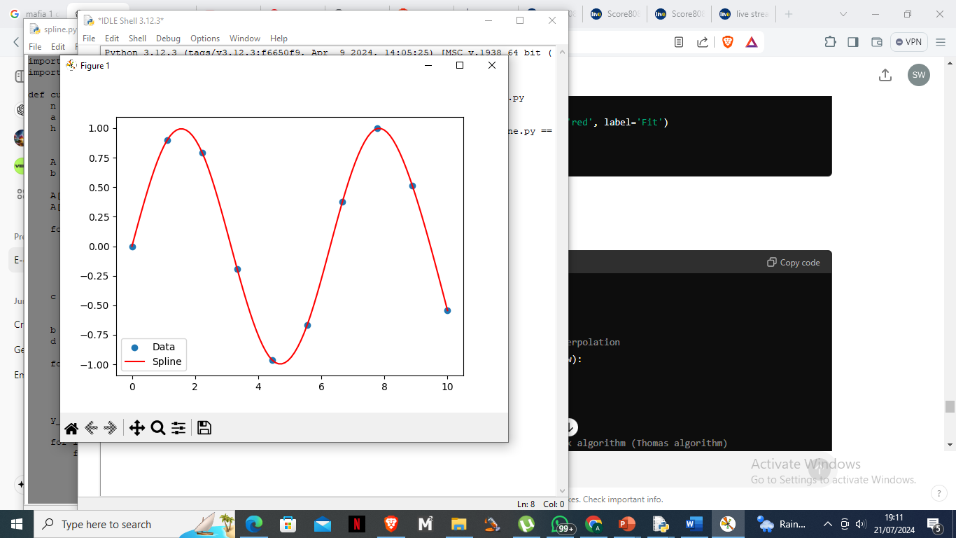

import numpy as np

import matplotlib.pyplot as plt

def cubic_spline_interpolation(x, y, x_new):

n = len(x)

a = y

h = np.diff(x)

A = np.zeros((n, n))

b = np.zeros(n)

A[0, 0] = 1

A[-1, -1] = 1

for i in range(1, n-1):

A[i, i-1] = h[i-1]

A[i, i] = 2 * (h[i-1] + h[i])

A[i, i+1] = h[i]

b[i] = 3 * (a[i+1] - a[i]) / h[i] - 3 * (a[i] - a[i-1]) / h[i-1]

c = np.linalg.solve(A, b)

b = np.zeros(n-1)

d = np.zeros(n-1)

for i in range(n-1):

b[i] = (a[i+1] - a[i]) / h[i] - h[i] * (c[i+1] + 2*c[i]) / 3

d[i] = (c[i+1] - c[i]) / (3 * h[i])

y_new = np.zeros_like(x_new)

for i in range(len(x_new)):

for j in range(n-1):

if x[j] <= x_new[i] <= x[j+1]:

dx = x_new[i] - x[j]

y_new[i] = a[j] + b[j]*dx + c[j]*dx**2 + d[j]*dx**3

return y_new

x = np.linspace(0, 10, 10)

y = np.sin(x)

x_new = np.linspace(0, 10, 100)

y_new = cubic_spline_interpolation(x, y, x_new)

plt.scatter(x, y, label='Data')

plt.plot(x_new, y_new, label='Spline', color='red')

plt.legend()

plt.show()

c) import numpy as np

# Given coordinates

x_coords = np.array([2.00, 4.25])

y_coords = np.array([7.2, 7.1])

# Point to interpolate

x_to_find = 4.0

# Linear interpolation

x1, x2 = x_coords

y1, y2 = y_coords

# Calculate the slope (y2 - y1) / (x2 - x1)

slope = (y2 - y1) / (x2 - x1)

# Calculate the interpolated y value

y_at_x = y1 + slope * (x_to_find - x1)

# Print the result

print(f"The value of y at x = {x_to_find} is {y_at_x}")

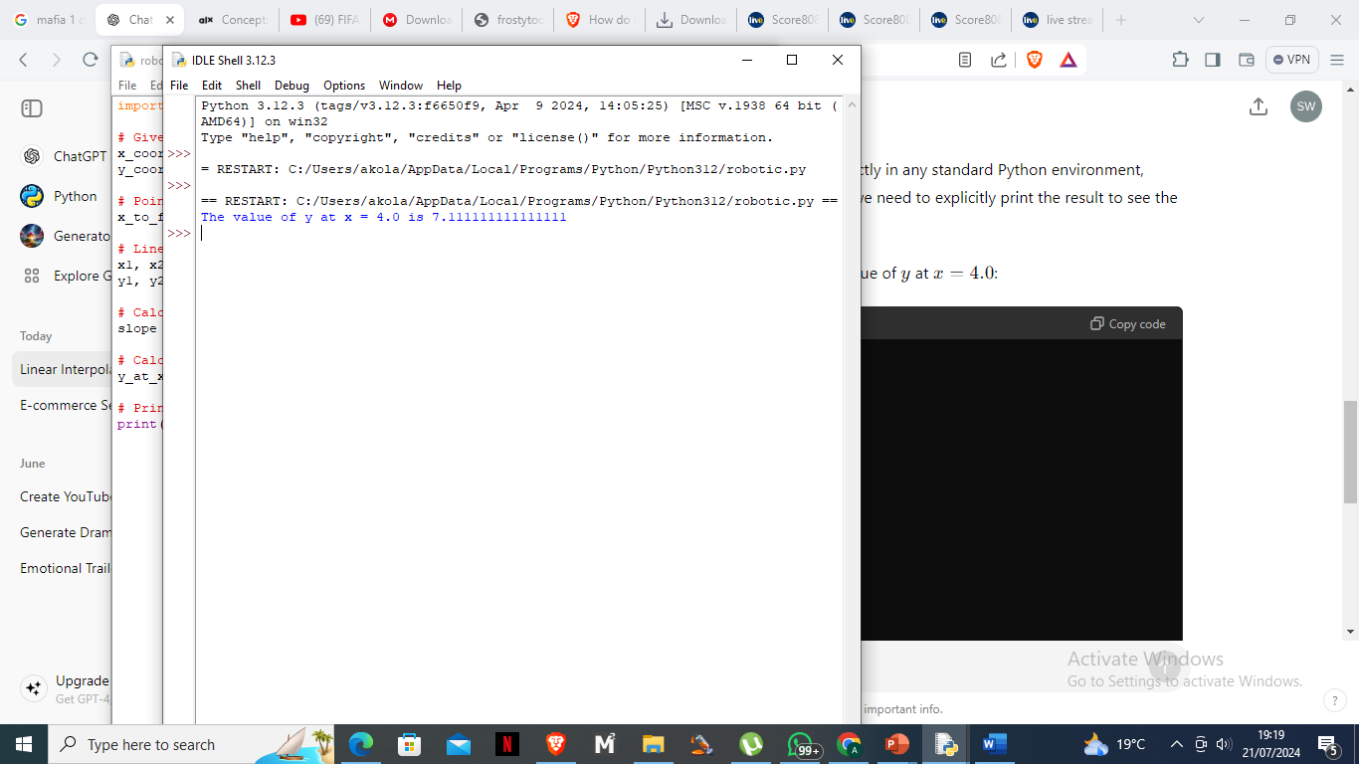

d)f(x)=0

xn+1=xn-(f(xn)/f’(xn))

f(x)=x3-0.165x2+3.993*10-4

f’(x)=3x2-0.33x

x1=xo-f(xo) /f’(xo)

f(0.05)=(0.05)3 – 0.165(0.05)2 + 3.993 * 10-4 = 1.25 * 10-4 – 0.004125 + 3.993 * 10-4= 0.00024975

f’(0.05)= 3(0.05)2 – 0.33(0.05) = 0.0075 – 0.016 = -0.009

x1 = 0.05 – 0.00024975/ -0.009 = 0.05 + 0.02775 = 0.07775

€1=│(x1 – x0)/x1│ * 100 =35.68%

Iteration 2

X2=x1 – f(x1)/f’(x1)

f(x1)=-0.000137

f’(x1)=-0.00755

x2 =0.07775 – (-0.000137)/(-0.00755)=0.07775+0.01815=0.0959

€= │(x2 – x1)/x2│* 100 = 18.88%

Iteration 3

X3 = x2 – (f(x2))/(f’(x2))

f(x2)= (0.0959)3 – 0.165(0.0959)2 + 3.993 * 10-4 =-0.000226

f’(0.0959)= 3(0.0959)2 – 0.33(0.0959) = 0.02755 – 0.03165 = -0.0041

x3 = 0.0959 – (-0.000226)/(-0.0041) =0.0959 + 0.05512 = 0.15102

€│(x3 – x2)/x3│* 100= 36.52%

e)

import numpy as np

import matplotlib.pyplot as plt

# Define the parameters

f1 = 50 # Frequency 1 in Hz

f2 = 120 # Frequency 2 in Hz

fs = 1000 # Sampling frequency in Hz

t = np.arange(0, 1, 1/fs) # Time vector for 1 second

# Define the signal

s = np.sin(2 * np.pi * f1 * t) + np.sin(2 * np.pi * f2 * t)

# Compute the FFT

S = np.fft.fft(s)

freq = np.fft.fftfreq(len(s), 1/fs)

# Plot the signal

plt.figure(figsize=(12, 6))

plt.subplot(2, 1, 1)

plt.plot(t, s)

plt.title('Signal in Time Domain')

plt.xlabel('Time [s]')

plt.ylabel('Amplitude')

plt.subplot(2, 1, 2)

plt.plot(freq[:len(freq)//2], np.abs(S)[:len(S)//2]) # Plot only the positive frequencies

plt.title('Signal in Frequency Domain')

plt.xlabel('Frequency [Hz]')

plt.ylabel('Magnitude')

plt.tight_layout()

plt.show()

f)

for n = 1:5

This loop will iterate 5 times, with n taking values from 1 to 5.

x = n * 0.1;

Within each iteration of the loop, x is computed as n * 0.1. This means:

When n = 1, x = 0.1

When n = 2, x = 0.2

The function myfunc2 is called with parameters x, 2, 3, and 7. Each value of x, z will be the result of myfunc2 with those arguments.

fprintf('x = %4.2f f(x) = %8.4f \r', x, z)

The fprintf function is used to print the values of x and z with specific formatting:

%4.2f formats x to have a width of 4 characters, with 2 digits after the decimal point.

%8.4f formats z to have a width of 8 characters, with 4 digits after the decimal point.

\r is a carriage return, which moves the cursor to the beginning of the line.

g)

import numpy as np

def trapezoidal_rule(func, a, b, n):

"""

Compute the integral of a function using the trapezoidal rule.

Parameters:

func : function

The function to integrate.

a : float

The start of the interval.

b : float

The end of the interval.

n : int

The number of sub-intervals.

Returns:

float

The approximate integral of the function.

"""

x = np.linspace(a, b, n+1)

y = func(x)

h = (b - a) / n

integral = (h/2) * (y[0] + 2 * np.sum(y[1:-1]) + y[-1])

return integral

# Define a sample function to integrate

def sample_func(x):

return x**2

# Set the interval and number of sub-intervals

a = 0

b = 1

n = 100

# Compute the integral

integral = trapezoidal_rule(sample_func, a, b, n)

print(f"The integral of the function from {a} to {b} is approximately {integral:.6f}")

# For visualization

import matplotlib.pyplot as plt

x = np.linspace(a, b, 1000)

y = sample_func(x)

plt.plot(x, y, label='f(x) = x^2')

# Trapezoids

x_trap = np.linspace(a, b, n+1)

y_trap = sample_func(x_trap)

plt.fill_between(x_trap, y_trap, alpha=0.3, label='Trapezoids')

plt.title('Trapezoidal Rule Integration')

plt.xlabel('x')

plt.ylabel('f(x)')

plt.legend()

plt.show()

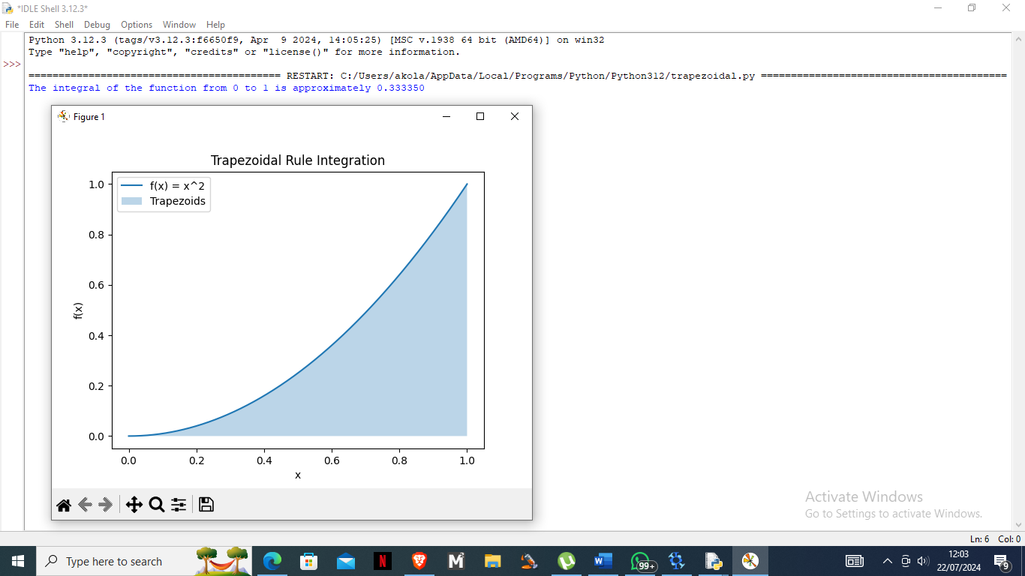

h)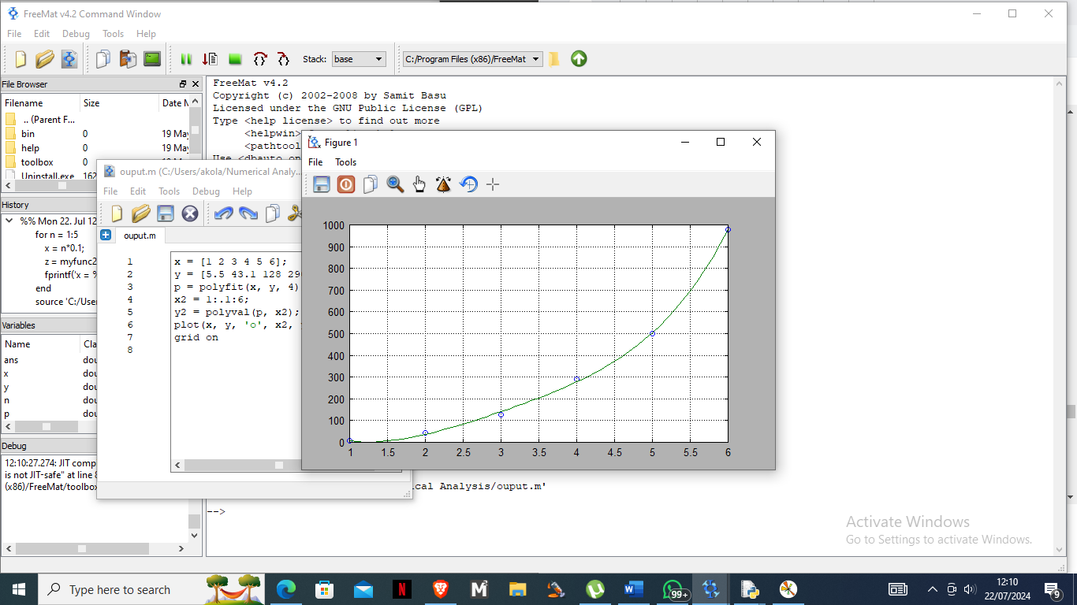

i) x and y define the data points.

ii) polyfit(x, y, 4) computes the coefficients of a 4th-degree polynomial that fits the data points (x, y).

iii) x2 creates a vector from 1 to 6 with increments of 0.1.

iv) polyval(p, x2) evaluates the polynomial with coefficients p at each point in x2.

v) plot(x, y, 'o', x2, y2) plots the original data points as circles and the polynomial fit as a line.

vi) grid on adds a grid to the plot.

i)

i) import numpy as np

def lagrange_interpolation(x, y, x_val):

n = len(x)

result = 0

for i in range(n):

term = y[i]

for j in range(n):

if j != i:

term = term * (x_val - x[j]) / (x[i] - x[j])

result += term

return result

# Given data points

x = np.array([1, 2, 3, 4])

y = np.array([1, 4, 9, 16])

# Evaluate at several points

x_vals = np.linspace(1, 4, 100)

y_vals = [lagrange_interpolation(x, y, xv) for xv in x_vals]

# Plot the results

import matplotlib.pyplot as plt

plt.plot(x, y, 'o', label='Data points')

plt.plot(x_vals, y_vals, '-', label='Lagrange Interpolation')

plt.xlabel('x')

plt.ylabel('y')

plt.legend()

plt.grid(True)

plt.title('Lagrange Polynomial Interpolation')

plt.show()

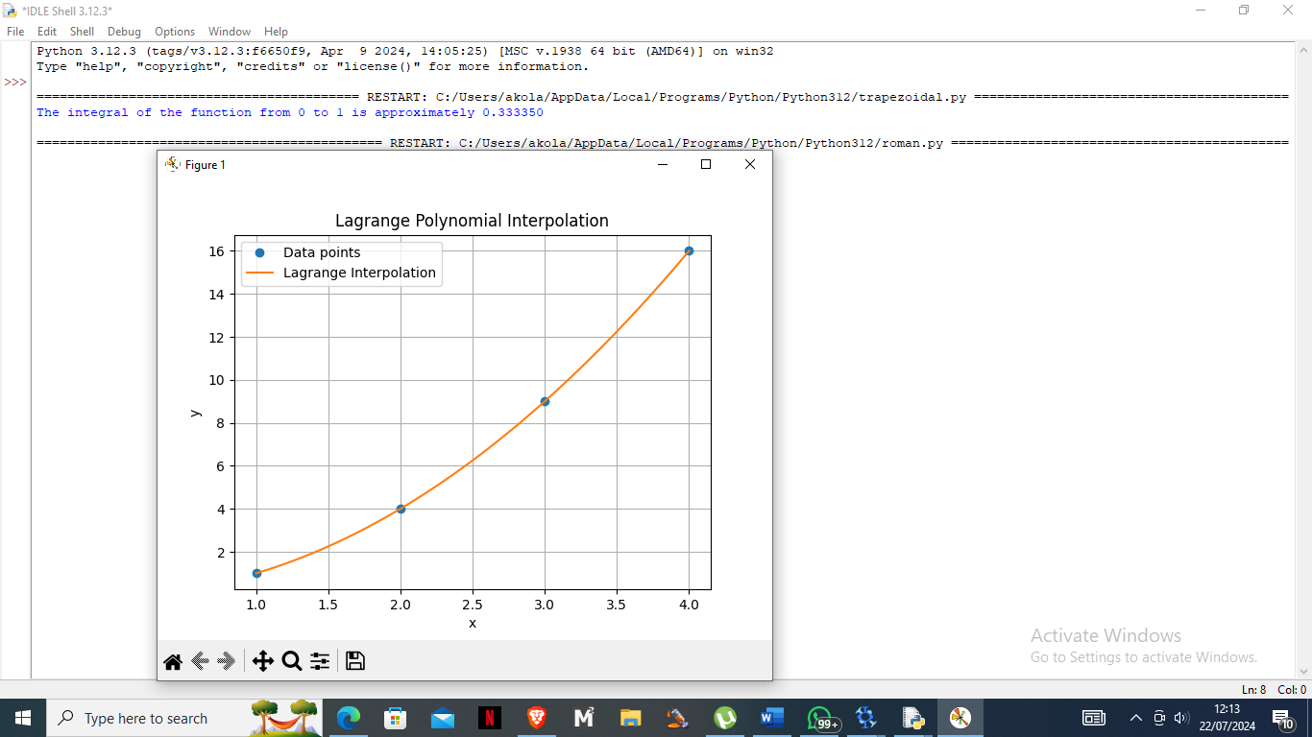

ii) def divided_diff(x, y):

n = len(y)

coef = np.zeros([n, n])

coef[:, 0] = y

for j in range(1, n):

for i in range(n - j):

coef[i, j] = (coef[i + 1, j - 1] - coef[i, j - 1]) / (x[i + j] - x[i])

return coef[0, :]

def newton_poly(coef, x_data, x):

n = len(coef) - 1

p = coef[n]

for k in range(1, n + 1):

p = coef[n - k] + (x - x_data[n - k]) * p

return p

# Given data points

x = np.array([1, 2, 3, 4])

y = np.array([1, 4, 9, 16])

# Calculate coefficients

coef = divided_diff(x, y)

# Evaluate at several points

x_vals = np.linspace(1, 4, 100)

y_vals = [newton_poly(coef, x, xv) for xv in x_vals]

# Plot the results

plt.plot(x, y, 'o', label='Data points')

plt.plot(x_vals, y_vals, '-', label='Newton Interpolation')

plt.xlabel('x')

plt.ylabel('y')

plt.legend()

plt.grid(True)

plt.title('Newton Polynomial Interpolation')

plt.show()

iii)

Lagrange Technique:  
  
Builds the polynomial directly from the supplied points.  
For a large number of points, the polynomial can become rather complex and computationally demanding.  
Not as effective when adding additional data points because it requires recalculating the polynomial in its entirety.

Newton’s Divided Difference Method:

Is more effective when building the polynomial sequentially for a greater number of points.  
added data points are easier to add without having to recalculate the entire polynomial.  
employs a recursive method, which has the potential to be more computer-efficient.

Comparison:

For short datasets, the outcomes from both approaches are the same.

Newton's approach is usually favoured for large datasets because of its flexibility and efficiency in adding new points.

j)

import numpy as np

def power_iteration(A, num_simulations: int):

# Choose a random vector to start with

b_k = np.random.rand(A.shape[1])

for _ in range(num_simulations):

# Calculate the matrix-by-vector product Ab

b_k1 = np.dot(A, b_k)

# Re normalize the vector

b_k1_norm = np.linalg.norm(b_k1)

b_k = b_k1 / b_k1_norm

eigenvalue = np.dot(b_k.T, np.dot(A, b_k)) / np.dot(b_k.T, b_k)

eigenvector = b_k

return eigenvalue, eigenvector

# Define the matrix

A = np.array([[4, 1, 1],

[1, 3, -1],

[1, -1, 2]])

eigenvalue, eigenvector = power_iteration(A, 1000)

print("Eigenvalue:", eigenvalue)

print("Eigenvector:", eigenvector)

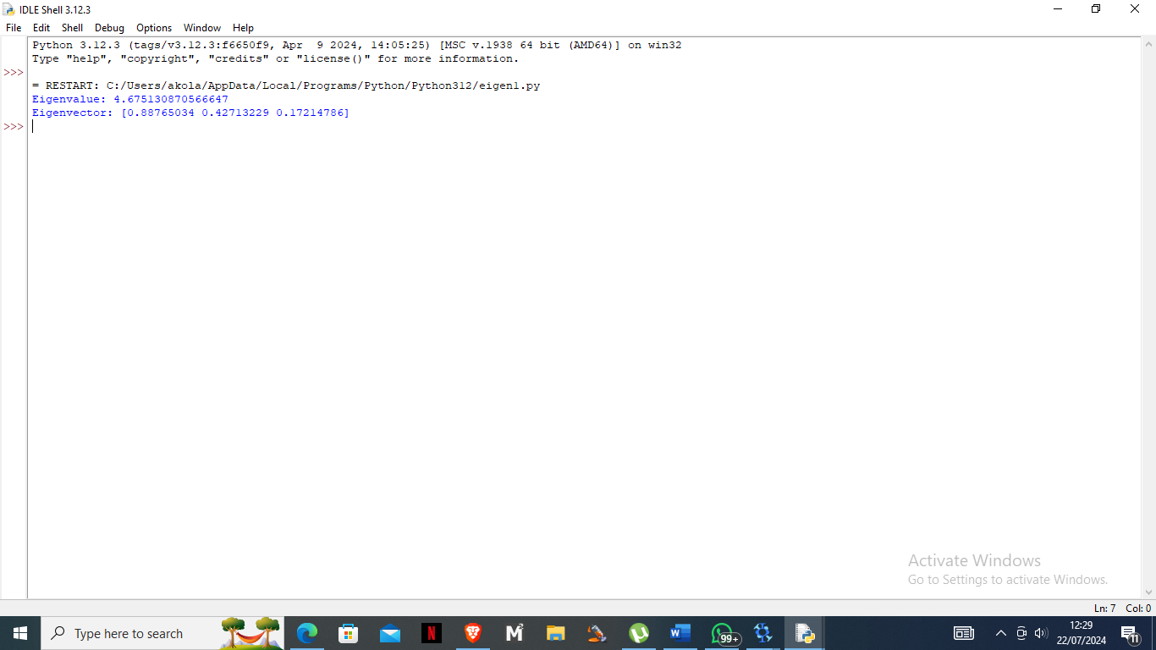

ii) def qr_algorithm(A, num_simulations: int):

Ak = A.copy()

Q_prod = np.eye(A.shape[0])

for _ in range(num_simulations):

Q, R = np.linalg.qr(Ak)

Ak = np.dot(R, Q)

Q_prod = np.dot(Q_prod, Q)

eigenvalues = np.diag(Ak)

eigenvectors = Q_prod

return eigenvalues, eigenvectors

# Define the matrix

A = np.array([[4, 1, 1],

[1, 3, -1],

[1, -1, 2]])

eigenvalues, eigenvectors = qr_algorithm(A, 100)

print("Eigenvalues:", eigenvalues)

print("Eigenvectors:")

print(eigenvectors)

iii)

Comparison:

Power Iteration Technique:  
  
Appropriate for determining the matching eigenvector and greatest eigenvalue.  
efficient in terms of computation for big matrices.  
If not altered, it might not find every eigenvalue or eigenvector.

QR Algorithm:  
Able to locate each eigenvalue's matching eigenvector.  
higher processing overhead than Power Iteration.  
Ideal for smaller matrices or situations requiring all eigenvalues and eigenvectors.

k)

import matplotlib.pyplot as plt

import numpy as np

def f(x, y):

return x**2 + y**2 - x*y + x - y + 1

def grad_f(x, y):

df_dx = 2*x - y + 1

df_dy = 2*y - x - 1

return [df_dx, df_dy]

def gradient_descent(starting_point, learning_rate, num_iterations):

point = list(starting_point)

points = [point.copy()]

for _ in range(num_iterations):

grad = grad_f(point[0], point[1])

point[0] -= learning_rate * grad[0]

point[1] -= learning_rate * grad[1]

points.append(point.copy())

return points

# Parameters

starting_point = [0, 0]

learning_rate = 0.1

num_iterations = 100

# Perform Gradient Descent

points = gradient_descent(starting_point, learning_rate, num_iterations)

# Extract points for plotting

x_points = [point[0] for point in points]

y_points = [point[1] for point in points]

# Create a grid of x and y values

x = np.linspace(-1, 2, 400)

y = np.linspace(-1, 2, 400)

X, Y = np.meshgrid(x, y)

Z = f(X, Y)

# Plot the results

plt.contour(X, Y, Z, levels=50)

plt.plot(x_points, y_points, 'r.-')

plt.title('Gradient Descent Optimization')

plt.xlabel('x')

plt.ylabel('y')

plt.show()

